West Village Eyecare Associates

 | Optometrist
10 Sheridan Square | New York, NY 10014 |  | Telephone (212) 242-6592

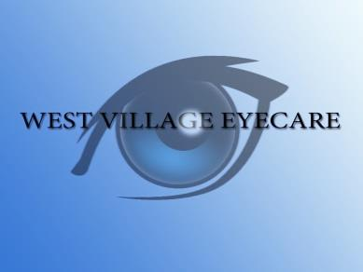

Policy for Placing New Lenses in Patient's Own Frame

We are happy to make new prescription lenses for your own frame if it's in good condition and fits your face properly. If we accept your frame for re-use, we pledge to use the utmost care in handling it. But in a small percentage of cases, the frame material will be worn or brittle to the point that it will not support a new pair of lenses.
Please be aware that older frame styles are often discontinued by the manufacturer and replacement parts are usually not available. This presents a problem if the frame breaks and can't be repaired.
If your frame breaks during our lens insertion process, the lenses initially made for that frame cannot be re-used for a different frame style. We will make new lenses at no additional charge for any new frame you choose, but the cost of the replacement frame will be at your expense.

I understand and accept this policy.
Patient's signature_____________________________ Date ___________

